We are absolutely thrilled you are interested to join us at Rohlik Group. By now we have spoken to you about your experience and personality in great detail. Next step is to find out how you tackle a task in reality.

**Fulfillment Center Manager**

**1, Situation**

On the busiest day of the week (Friday), 20% of the planned headcount for the outbound (30 people) does not show up in the morning shift. (The shift was 5% overplanned to compensate general no-show.) The planned daily timeslots were bought by the customers, the day is sold out and there would still be customer demand for additional orders. At 0730 hrs in the morning you will receive the following information and instructions:

- You will receive a request from senior management by email to get the most out of the day, to reach 4,000 orders instead of the planned 3600.

- The inbound manager informs you that here are the 10 people we have ordered for labeling, but the goods to be labeled have not arrived. Wondering if to send the 10 people home to meet operating cost expectations.

- The logistics shift manager informs you that due to the high traffic it is uncertain how the couriers will return from their first round

- The quality department reports that during the early morning inspection a number of damaged fruit and vegetables were found in the refrigerated bags prepared for transport.

With the above in mind, outline what consultations you will initiate, what actions / decisions you will make and what you will communicate to your leaders, peers, and your own team!

**2, Cost management**

The main indicator of operational costs is Labor Cost per Order.

LC monitoring includes - daily staff costs (WH management + agency staff) / number of orders

The development of LC last month was as follows:

This cost also includes the operation of receiving goods, which corresponds to 30% of the total daily cost.

During the meeting with your superior, you have to explain why there were fluctuations in the mentioned period and especially higher LC, and at the same time prepare measures on how to keep the LC at the level of 97 CZK / order in the following month.

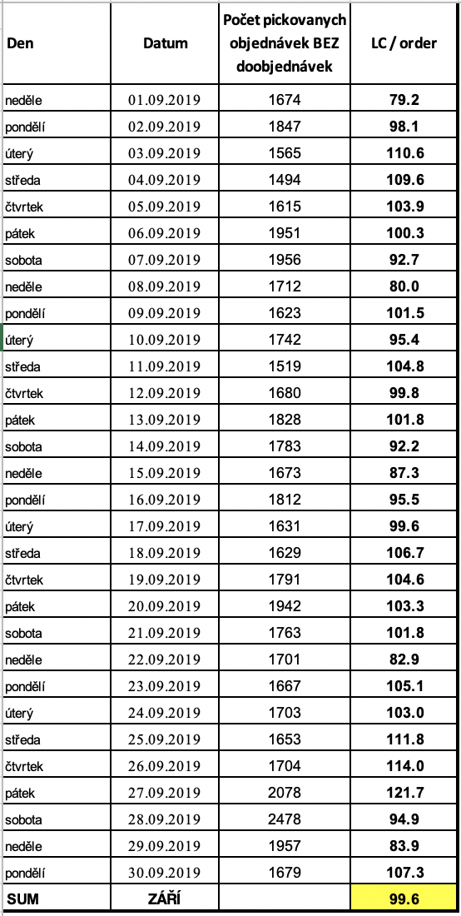

**3, Analytics / performance management**

In the attached xls you will see the picking performance of the warehouse for the recent weeks.

performance category = picking zone code

spent time in sec = time spent (sec) with the given activity (registered by the WMS)

performance = picking jobs completed

Judge the performance of the warehouse and define improvement opportunities / corrective measures.

**Format**

Result of the case study should be captured in a format of your choice that is easily shareable with us during the next meeting. We don’t need you to write essays, clear and consistent content is much more important to us. Please send us the presentation materials of your Case study 1 day prior to the meeting so we can review and get ready for the talk.